# Documentation for the CCF Assignment:

## 1- Functional Requirements:

The game is designed around a 2D maze where the start and exit points are fixed. The size and structure of the maze, along with the start and exit points, are predefined and remain constant throughout the game. The Maze grid is drew using some CSS styling. (Maze.css)

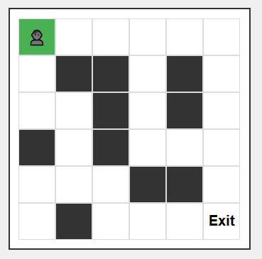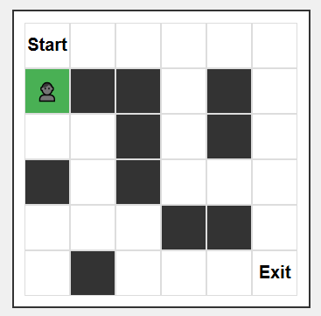

At the start, the player begins at the designated starting point and is initially facing right. The player can change their direction at any time by either clicking the direction buttons in the UI or using the arrow keys on the keyboard.



After selecting a direction, the player can move forward by pressing the "Enter" key or by clicking the "Move Forward" button in the UI.



For simplicity, I assumed that the entire maze is visible to the player from the start, although this decision was made to avoid the added complexity and obviously will make the UI less appealing.

The overall look of the UI:

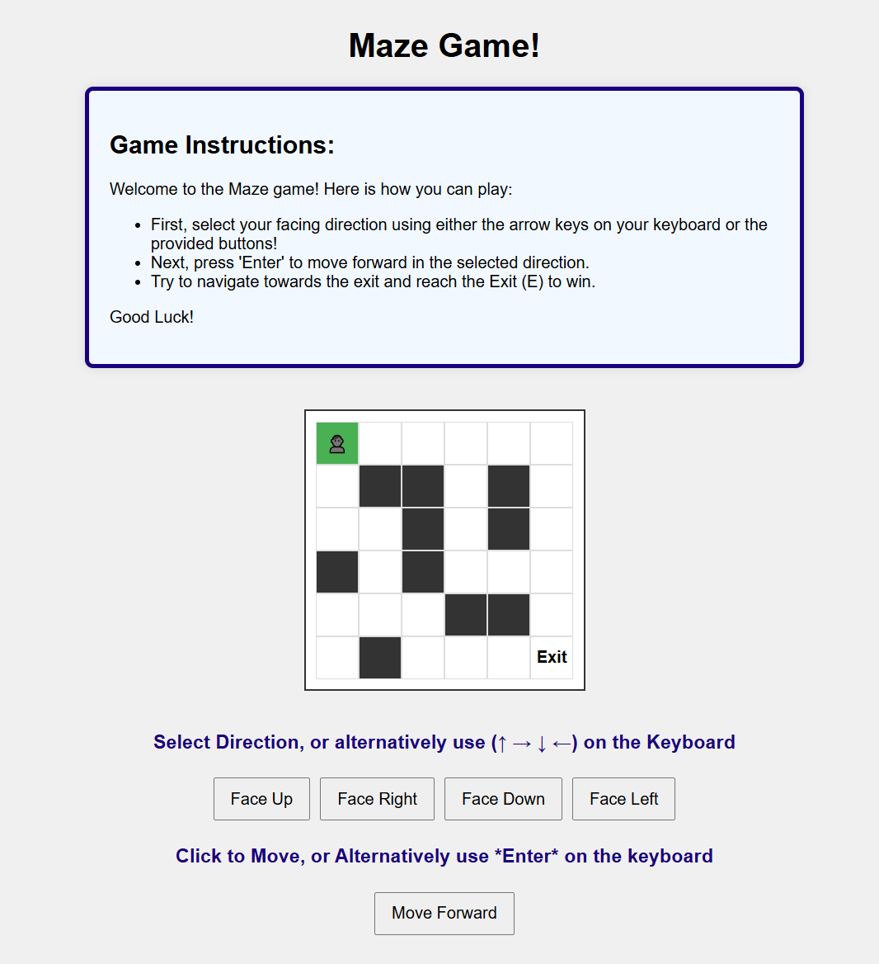

Once the user reaches the exit point, a green 'End Game' message will appear at the bottom of the screen, and the user will no longer be able to make any further moves.

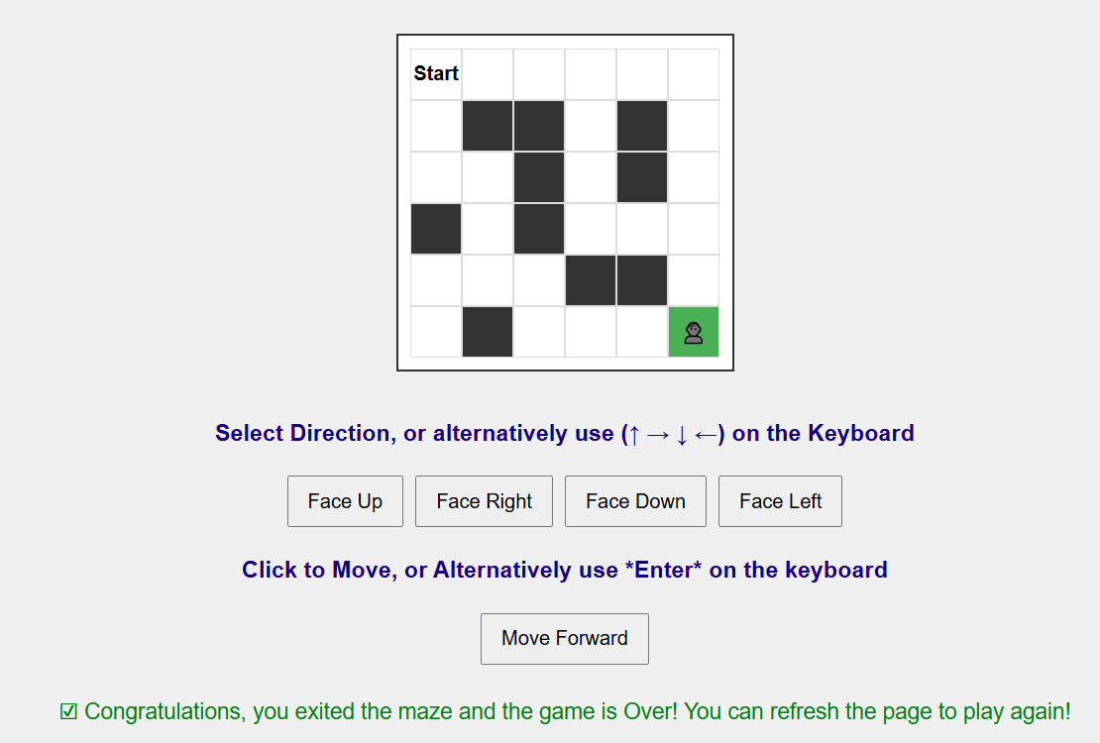

**Missing functional Requirement:** I was unable to implement the feature that renders the 2D maze in a 3D perspective from the user's point of view (starting at the entry). The goal was to provide a limited view of the maze based on the direction the user is facing, enhancing the game's visual appeal. However, I didn’t fully understand the specific requirements or how to implement this feature, and due to time constraints, I was unable to complete it. I apologize for the oversight.

**Bonus Clauses:** As for the bonus clauses, I chose not to include any of the bonus features, as I am still in the early stages of learning React and JavaScript. My focus was to keep the functionality simple and to build a solid foundation for future improvements.

## 2- How to Run the Code: